Practical 17 :

Code :

class Vehicle{

    void run(){

        System.out.println("Vehicle is running");

    }

}

public class Over extends Vehicle {

    void run(){

        System.out.println("Over is running");

    }

    public static void main(String[] args) {

        Over o = new Over();

        o.run();

    }

}

Output :

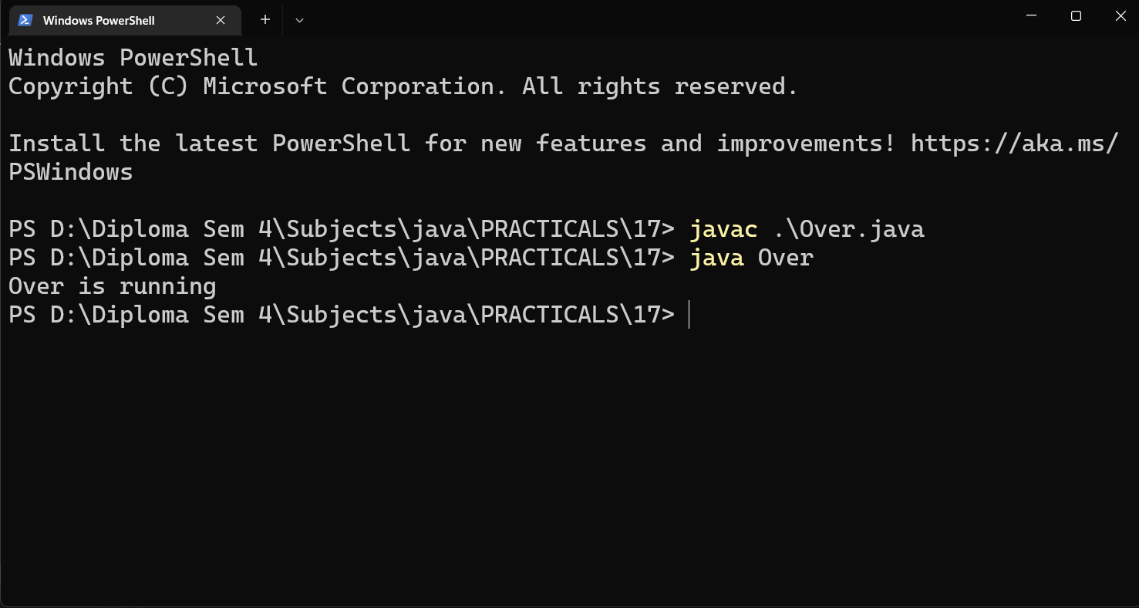

Code :

class Bank{

    int Interest(){

        return 0;

    }

}

class SBI extends Bank{

    int Interest(){return 8;}

}

class HDFC {

    int Interest(){return 10;}

}

class MAHARASHTRA{

    int Interest(){ return 7;}

}

public class RateOfInterest {

    public static void main(String[] args) {

        SBI a =new SBI();

        HDFC b = new HDFC();

        MAHARASHTRA c =  new MAHARASHTRA();

        System.out.println("Rate of Interest Of SBI : "+a.Interest());

        System.out.println("Rate of Interest Of HDFC : "+b.Interest());

        System.out.println("Rate of Interest Of MAHARASHTRA : "+c.Interest());

    }

}

Output :

